**Real-Life Applications of Trigonometry: A Student Worksheet**

**Tangent (Trigonometry): Example from Architecture and Construction**

1. **Determining the Optimal Size of a Roof Overhang with the Help of Tangent**

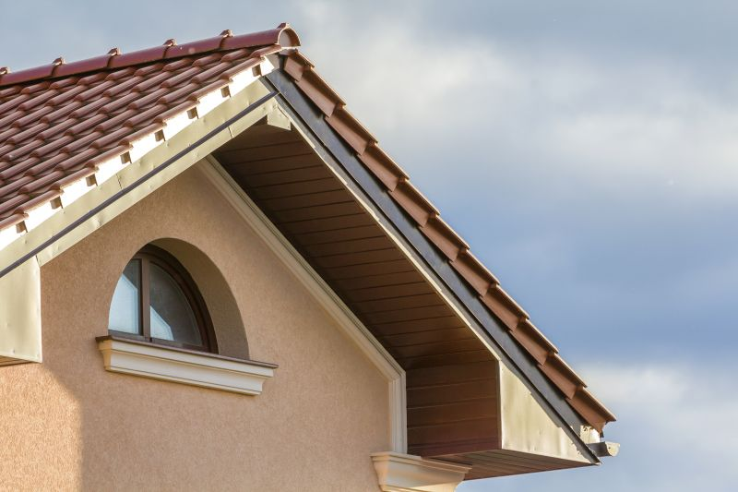

Roof overhangs are important architectural features that provide several benefits:

* Sun Protection: They offer shade, reducing the amount of direct sunlight entering windows, which helps in cooling the building and reducing energy costs.
* Rain Protection: Overhangs help protect walls and windows from rain, reducing the risk of water damage.
* Aesthetic Appeal: Overhangs contribute to the architectural style and visual appeal of a building.

To maximize these benefits, it’s crucial to calculate the optimal size of the overhang based on the sun’s position at different times of the year.

1. **Using Tangent to Calculate Roof Overhang for Sun Protection**

Let’s walk through a practical example to understand how the tangent function is used to calculate the optimal roof overhang.

Imagine a model of a house. Suppose we want to create an overhang that blocks the high summer sun (approximately from late April to early August) but allows lower winter sun to enter:

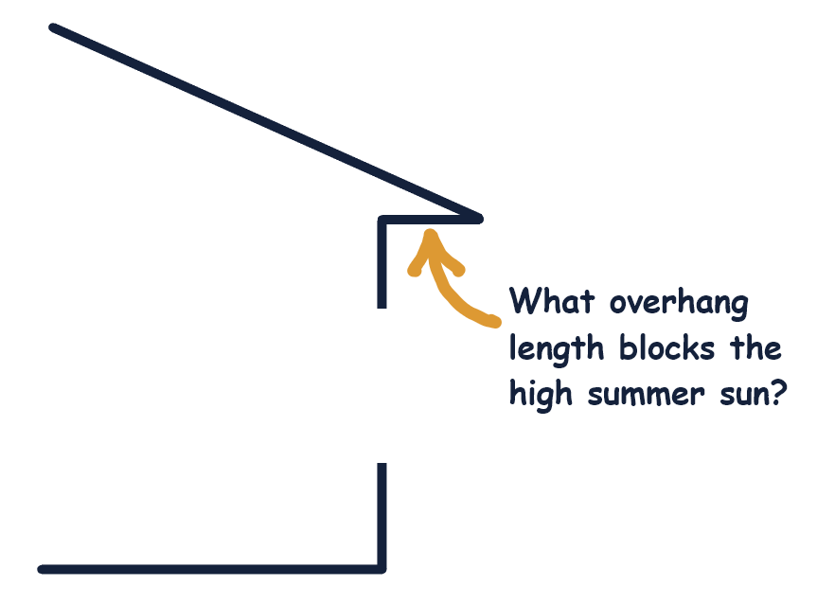

In the triangle ABC, leg AB is the distance from the bottom of the window to the roof overhang. In our example, this length is **6 feet**. Leg BC is the length of the overhang that we need to determine, and AC is the hypotenuse that lies on the ray “r” representing the direction of the sunrays.

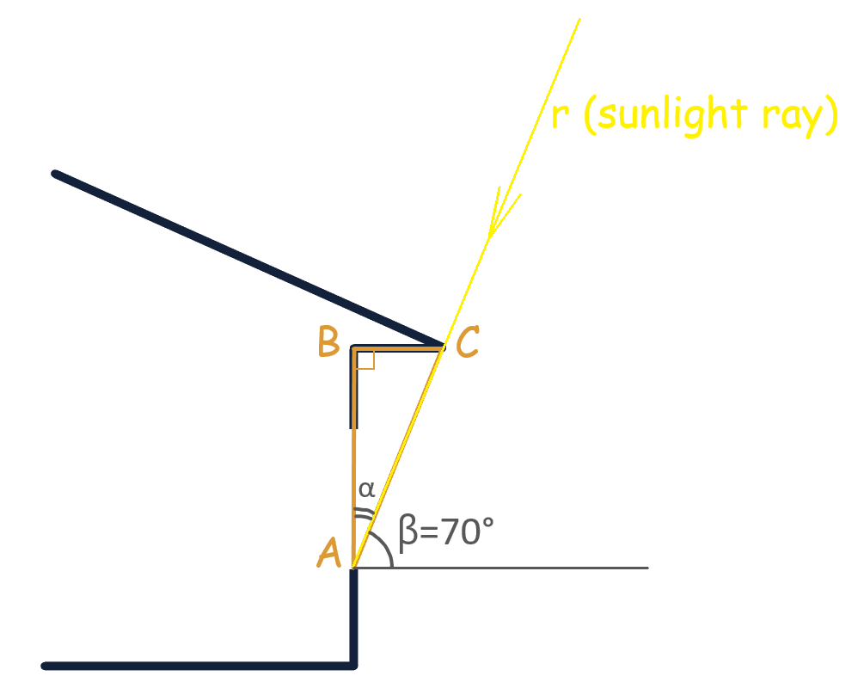

Find the length of the overhang using tangent function. (Florida example: During summer peak heat, solar angle β = 70°).