POLYNOMIALS
https://dartef-education.web.app/SNA_15a
It is possible to describe and model very different processes with the help of polynomials. Following program will show You one application of polynomials.
Nowadays, plants are not growing only in the outdoor farms – but there are also indoor farms (also called vertical farms): special buildings, where it is possible to grow plants throughout the years: for example lettuce, radish, parsley, etc. You can make a search in YouTube with keywords „vertical farming“ or „indoor farming“. In these farms it is possible to create optimal conditions for growing: illumination, irrigation, pests prevention, etc.
In order to prevent pests and disease, plants are being sprinkled with special liquids, that kill harmful bacteria. These liquids must be prepared very carefully and in necessary volumes.
Next program will help You to model automatic sprinkling system for preventing pests and diseases, with the help of polynomials.

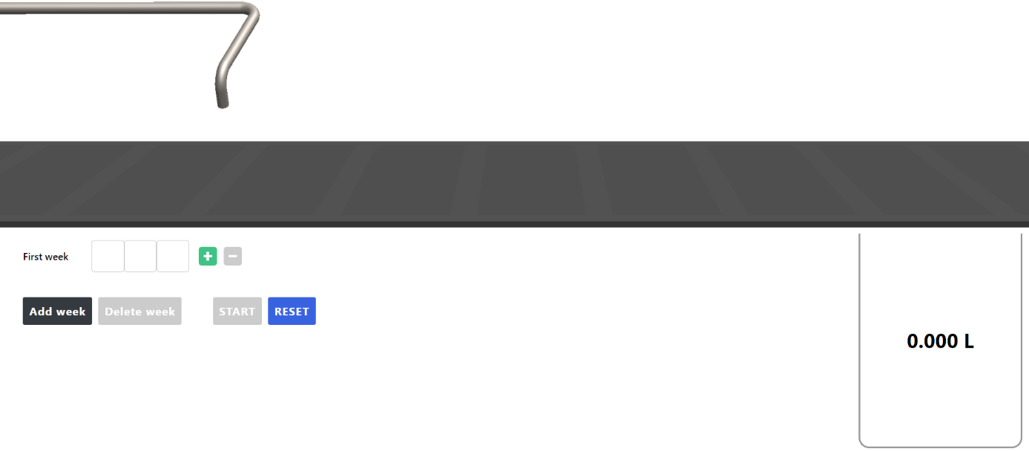
To insert polynomial, just click on each box, and keyboard will be opened. Press to add another monomial

In this program, You can see conveyor, where boxes with plants are moving under the pipe. Special liquid for pests and disease prevention is sprinkling from this pipe. This vertical farm is highly automated and sprinkler system must know exactly – how much liquid it must sprinkle to different boxes.
Introductory exercise:
Let’s agree, that we need to sprinkle 2 boxes with radishes and 3 boxes with parsley. Sprinkling algorithm can be described as polynomial $2ax+3by$. Let’s have detailed look:
Monomial „$2ax$“ means:
- „2“ is two boxes;
- „$a$“ is the are of radishes leaves (in cm²);
- „$x$“ is amount of liquid, that is needed for one cm² of radish).
Put $2ax$ into software. For “$a$” put 2 cm², and for “$x$” put 10 ml per cm²:
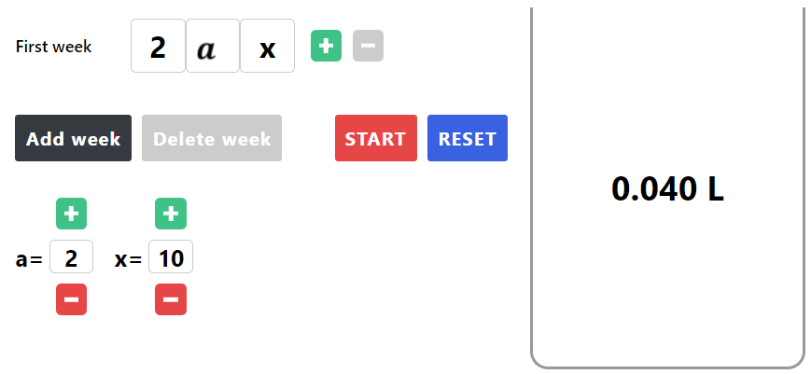
Question 1: what amount of liquid we need to prepare?
In order to know amount of liquid, we must put mentioned values into monomial$2ax$, i.e.: $2*2*10=40ml$. You can check the answer also in program.
Press START, and see how sprinkling is working. If everything is made correctly, two boxes will be moving on the conveyor, each requiring 20ml of sprinkling liquid.
You can now put second monomial into program ($3by$). You can select area of leaves and amount of liquid Yourself.
Exercises:
Use following variables:
- $a$: Radish;
- $b$: Parsley;
- $x$: amount of liquid needed per cm² radish;
- $y$: amount of liquid needed per cm² parsley.

Exercise 1:
Create monomial, that would describe following sprinkling algorithm:
- 3 boxes of radish. Area of radish leaves is 3 cm², 10 ml is required per cm²;
- 4 boxes of parsley. Area of parsley leaves is 4 cm², 15ml is required per cm^{2.}
Answers:
- The polynomial describing sparkling algorithms is______________________________.
- The amount of necessary sprinkling liquid is ________, whereas _______ ml is needed for radish and ________ is needed for parsley.
You can check Your answers also in program.

Exercise 2:
Add 3 boxes with parsley to the polynomial from previous exercise (area of parsley leaves is also 4 cm², 15ml is required per cm2). What monomial You would add? Add this monomial to previous polynomial and simplify expression.
Answers:
- The monomial corresponding to 3 boxes with parsley is_____________.
- Simplified expression is: _______________________________________________.
- The amount of necessary sprinkling liquid is ________, whereas _______ ml is needed for radish and ________ is needed for parsley.
You can check Your answers also in program.

Exercise 3:
3a) During week 1, plants were sprinkled with algorithm $5ax + 7by$. During week 2, there was two boxes with parsley less. What algorithm would be needed for that?
Answer: $5ax + 7by - 2by$ = ___________________________

3b)
- Area of radish leaves is 5 cm², 20ml of liquid is necessary per cm²;
- Area of parsley leaves is 3 cm², 12ml of liquid is needed per cm².
How much liquid is needed for sprinkling plants during week 1 and during week 2?
Answer: for week 1 it is needed ________ l of liquid and for week 2 _______ l of liquid is needed.
Solution (write here, how You calculated these amounts):

Exercise 4:
During week 1, plants were sprinkled with algorithm $5ax + 7by$.
- Area of radish leaves is 5 cm², 20ml of liquid is necessary per cm²;
- Area of parsley leaves is 3 cm², 12ml of liquid is needed per cm².
By week 2 area of parsley leaves has squared. What would be the polynomial necessary to describe sprinkling algorithm for week 2?
Answers:
- Polynomial describing sprinkling algorithm for week 2 is ___________________________________.
- The amount of necessary sprinkling liquid for week 2 is ________, whereas _______ ml is needed for radish and ________ is needed for parsley.
Solution (write here, how You calculated these amounts):

Topics for classroom discussion (or short essay, if worksheet is given as homework):
- Is it convenient to use polynomials for creation of sprinkling algorithm?
- What other methods could You propose for creation of sprinkling algorithms?
- What else can be described with the help of monomials and/or polynomials?

Possible students’ questions and answers to these:
Q: Do real vertical farms really use polynomials for making sprinkling algorithms?
A: Different companies may create very different algorithms – and some of these algorithms can really use polynomials. It is important to understand – that the concept of polynomial is very universal, and it can be used for very different things, not only for sprinkling algorithm. This is the case for the whole mathematics – if You understand mathematics – You are able to create new things, not just consume what somebody else has created.

