Quadratic function and its graph
https://dartef-education.web.app/SNA_6a

Comets and asteroids are objects that move in space and follow orbits, which are similar to parabola in shape. Small unmanned spacecrafts can be launched into space to the orbits that are also similar to parabola. If the orbit can be described with parabola equation – it means, that humans can make necessary calculations. These calculations help to send spacecrafts to space, to the Moon, Mars and eventually to comets and asteroids. Relatively recently NASA sent spacecraft that was able to touch the surface of Bennu asteroid – You can read about it in Wikipedia.
Following program will help You to understand, how orbits of space objects are calculated and how these calculations help to launch spacecrafts into the space.
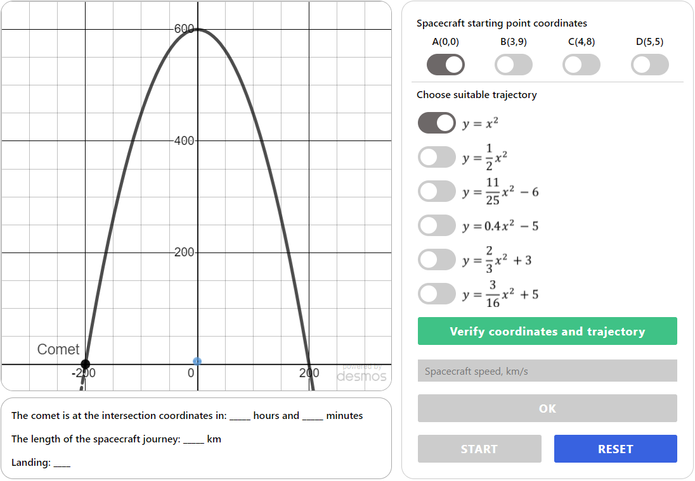
Planet, from which spacecraft must be launched (You can zoom)
Comet moving along parabolic trajectory
In this program You have a planet, from which the spacecraft is launched and comet, that is moving along parabolic trajectory. This program allows You to make simulation of spacecraft launch. Your task is to propose suitable starting point, trajectory and speed of the spacecraft – so that it would successfully land onto the comet.
The spacecraft launch depends on where starting coordinates are located. Launching spacecraft from USA, French Guiana or Russia requires different trajectories. Space agencies use its own coordinate system – we will use usual Cartesian coordinate plane, that You already know.
At first, choose one of four starting point coordinates: .
When starting point coordinates are selected, choose the trajectory that is suitable for these starting points. For some coordinates more that one trajectory is suitable – so, check all coordinates.

Answers:
I selected point __________ for starting point coordinates.
This starting point belong/doesn’t belong to trajectory described as $y=x^{2}$, because (write solution):

This starting point belong/doesn’t belong to trajectory described as $y=\frac{1}{2}x^{2}$, because (write solution):

This starting point belong/doesn’t belong to trajectory described as $y={\frac{11}{25}x}^{2}-6$, because (write solution):

This starting point belong/doesn’t belong to trajectory described as $y={0.4x}^{2}-5$, because (write solution):

This starting point belong/doesn’t belong to trajectory described as $y={\frac{2}{3}x}^{2}+3$, because (write solution):

This starting point belong/doesn’t belong to trajectory described as $y={\frac{13}{16}x}^{2}+5$, because (write solution):

Now, when starting point coordinates are selected, press button „Verify coordinates and trajectory“. If coordinates and trajectory are correct, the program will show You 3 things:
- Intersection point, where the comet and the spacecraft will meet;
- The time needed for comet to travel to the intersection point;
- The distance needed for spacecraft to travel to the intersection point.
Use this data to calculate what should be the spacecraft speed so that it would reach the comet at the right time and enter it into program.
Answer: spacecraft speed must be _______ m/s (use only one digit after decimal point, e.g. 5.5).
Press OK and then START to launch the spacecraft. If Your calculations are correct, then spacecraft will reach the comet successfully. You can use zoom to see intersection point better.
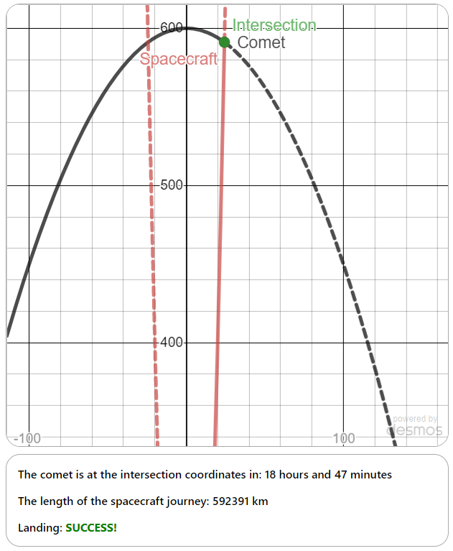
Of course, calculations used in space industry are more complex – however the principle is very similar to what You just did.

Topics for classroom discussion (or short essay, if worksheet is given as homework):
  - Look at the picture from program (zoom to planet):
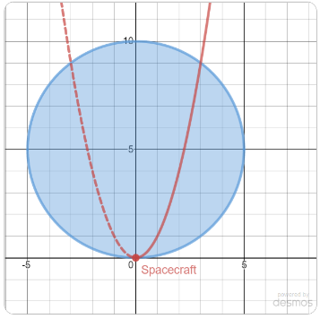
How many different starting point coordinates on earth can be there theoretically for launching spacecrafts?

  - Make small research and investigate what other types of trajectories exist for comets and spacecrafts. How these differ from parabolic trajectory?

Possible students’ questions and answers to these:
Q: I have read about landing on comets and asteroids – and saw that spacecrafts travel months or even years to reach them!
A: Good work – and absolutely right remark! Travel to space objects can take years. For example, spacecraft OSIRIS-REx was launched in September 2016, it landed on asteroid Bennu in September 2020 and expected to return to Earth in September 2023. The basic principles of mathematics and physics that are used to calculate trajectories are similar to what we did in program.

Q: Comets and asteroids travel around sun, so their orbits can’t look like parabola!
A: Very good remark! Indeed, orbits are „closed“, so that comets, asteroids and planets always return to same point. But parabolic orbits exist as well. The thing is: orbit of space object is very often complex, and can be represented via different functions at different locations. It means, that in one place, orbit can be parabolic, at another place orbit can be elliptic and so on. Orbits can be represented in many different ways and majority of them can be described with mathematical language.

These orbits might not be exactly of parabola shape, but still very close to it.

