Proportions
https://dartef-education.web.app/SNA_12a

Properties of mathematical proportions are widely used in geography. Probably You even have already solved exercises related to map scale.
Sometimes there is a need to show some important data on geographical map – for example population in different cities or countries. It is possible to write these numbers on the map. However, it is better to show this data graphically, for example with the help of circumferences.
The following program will help You to understand how this can be done.
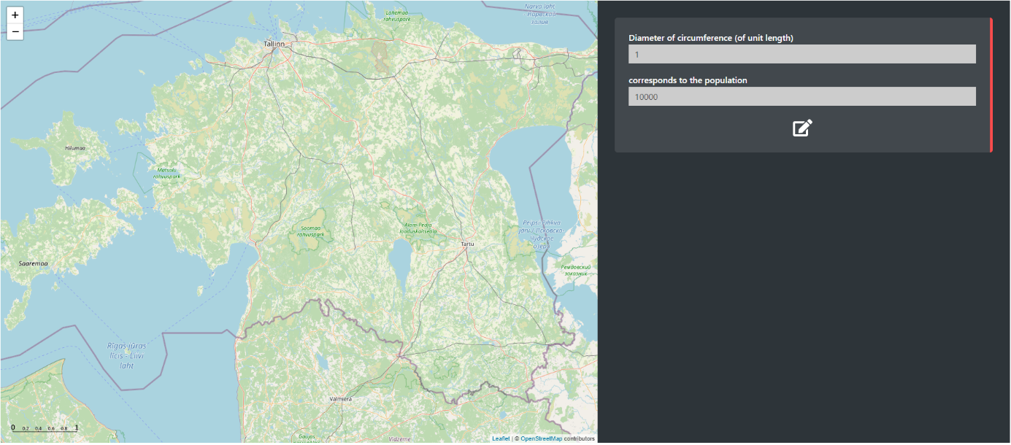
Click here to define proportion
Introductory exercise:
At first, please note so called “unit length” in the lower left corner of the map. Let’s agree, that circumference with the diameter of one unit length corresponds to 10000 of the population. By using proportion, it is possible to calculate, what circumference would be needed to show a place, where e.g. 20000 people live:
$\frac{1(unit length)}{x (unit length)}=\frac{10000 (population)}{20000 (population)}$.
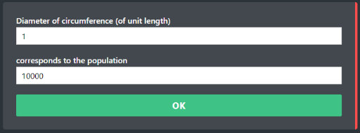
Solving this proportion gives us circumference with the diameter of 2 unit lengths.

Now, make the same in program. At first – define proportion (click on ). When proportion is defined, click OK.
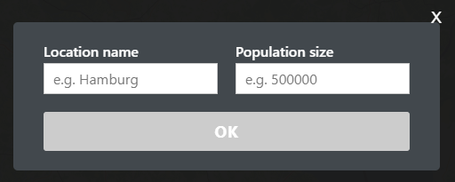

Then, click on any random place on the map. The window will open:

In this window write any city You want, and put 20000 as population size. If everything is done properly, the program will draw a circumference, which diameter equals 2 unit lengths (click on circumference to see data).
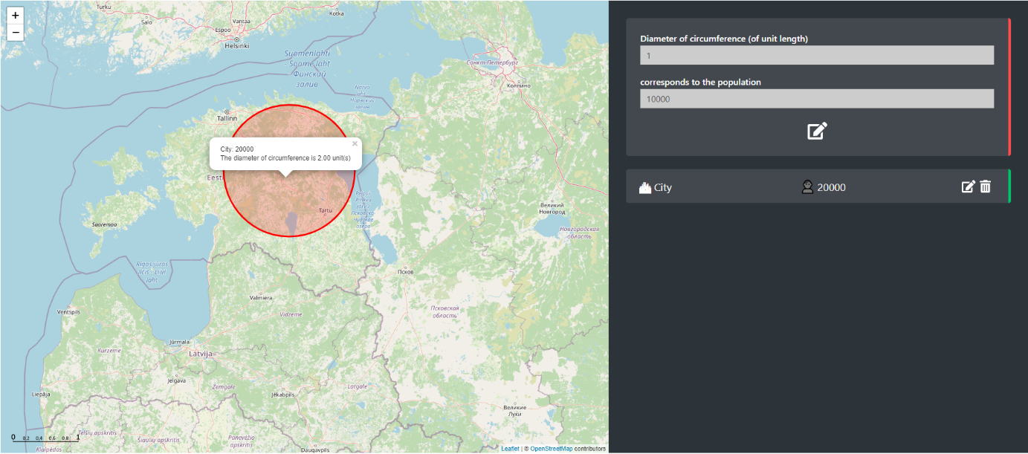

Exercise 1: five biggest cities in Estonia
This worksheet is translated from Estonian. When testing, of course You can make same exercise for Your own country in exactly same way!
Now, use program to show the population of five biggest cities in Estonia: Kohtla-Järve, Pärnu, Narva, Tartu and Tallinn.
Define following proportion: 1 unit circle corresponds to population of 50000. Then, click on the map where following cities are located and insert their population: Kohtla-Järve (32897 inhabitants), Pärnu (51334), Narva (55118), Tartu (95082) and Tallinn (445338).
How would You evaluate this map? Is it convenient to use this map to understand population of five biggest cities in Estonia or should we change something? Which ration between the diameter of the circumference and amount of population would be more suitable? Try different options, and give Your answer!
Note, that when defining proportion, You can change both diameter of circumference (You can use decimal fractions, e.g. 0.1) – as well as population size.
You can change both diameter of circumference – as well as population size.

Answer:
In my opinion, suitable ratio is when circumference with diameter of _______ unit length corresponds to ____________ of population. In this case:
- For Tallinn it will be circumference with diameter of __________ unit length,
- For Tartu it will be circumference with diameter of __________ unit length,
- For Narva it will be circumference with diameter of __________ unit length,
- For Pärnu it will be circumference with diameter of __________ unit length,
- For Kohtla-Järve it will be circumference with diameter of __________ unit length,

Exercice 2: capitals of counties in Estonia
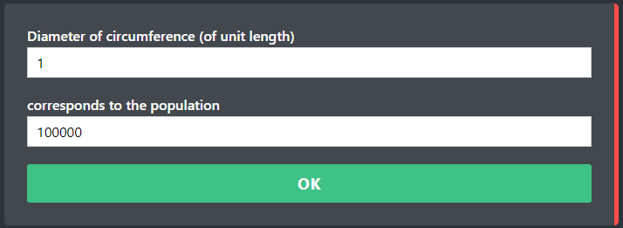
Create a map that shows capitals of Estonia counties. When defining proportion, use the population of 100000 inhabitants – and change only the diameter the circumference:
Change only diameter

Answers (we think that You might not know the population and location of these cities. We put population in red for You, so that You can test exercise – but of course You can do similar exercise for Your own country):
The circumference with diameter of ________ unit length must correspond to 100000 inhabitants. In this case:
- For Tallinn (445338) it will be circumference with diameter of __________ unit length,
Solution (write here, how You solved this proportion):

- For Kärdla (3050) it will be circumference with diameter of __________ unit length,
- For Jõhvi (11234) it will be circumference with diameter of __________ unit length,
- For Jõgeva (13329) it will be circumference with diameter of __________ unit length,
- For Paide it (10306) will be circumference with diameter of __________ unit length,
- For Haapsalu (12999) it will be circumference with diameter of __________ unit length,
- For Rakvere (14941) it will be circumference with diameter of __________ unit length,
- For Põlva (13663) it will be circumference with diameter of __________ unit length,
- For Pärnu (51334) it will be circumference with diameter of __________ unit length,
- For Rapla (13047) it will be circumference with diameter of __________ unit length,
- For Kuressaare (13276) it will be circumference with diameter of __________ unit length,
- For Tartu (95082) it will be circumference with diameter of __________ unit length,
- For Valga (15436) it will be circumference with diameter of __________ unit length,
- For Viljandi (16899) it will be circumference with diameter of __________ unit length,
- For Võru (11560) it will be circumference with diameter of __________ unit length,

Exercise 3: Estonia, Finland, Sweden and Norway capitals population
In 2020, population of Tallinn was 437619 inhabitants, Helsinki population was 656250 inhabitants, Stockholm population was 1605030 inhabitants and Oslo population was 1019513 inhabitants.
In order to define proportion, use Your birth year and birth day. For example, if You was born on July 15th 2009, then use it for defining proportion in following way: 15+2009=2024 and add two zeroes:
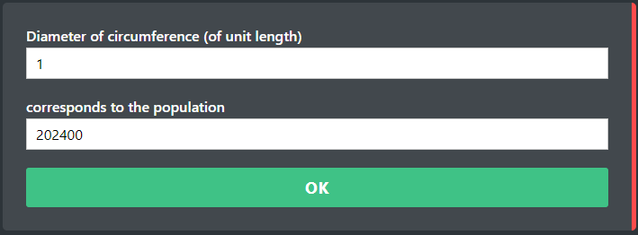
Then, find unit length, that You consider suitable.

Answers:
Suitable proportion is when circumference of _______ unit lengths, corresponds to _________ population. In this case:
- For Tallinn it will be circumference with diameter of __________ unit length,
Solution (write here, how You solved this proportion):

- For Helsinki it will be circumference with diameter of __________ unit length,
Solution (write here, how You solved this proportion):

- For Stockholm it will be circumference with diameter of __________ unit length,
Solution (write here, how You solved this proportion):

- For Oslo it will be circumference with diameter of __________ unit length,
Solution (write here, how You solved this proportion):

Paste here the screenshot of the map that You have got.
Topics for classroom discussion (or short essay, if worksheet is given as homework):
- Is it convenient to use proportions for creation of visual maps?
- What else would You put on the map, that can be changed with the help of proportions?

Possible students’ questions and answers to these:

