Calculating percentage from number
https://dartef-education.web.app/SNA_10a

Adult person must make ca. 10000 steps per day in order to keep normal physical activity. It means, that person must make 10000 steps in order to make 100% of daily target. Many people don’t move a lot during their working day (e.g. those, who work in office), so they move less than 100% of the daily target. Many people nowadays use different smart watches and activity monitors – that help people to track their daily activity.
Activity monitor has special sensor – step counter. It follows how many steps per day person does and then calculated how many percentages of daily target is fulfilled or not.
Following program will show You, how these activity monitors can calculate percentages. It will help You to better understand, how percentages can be used.

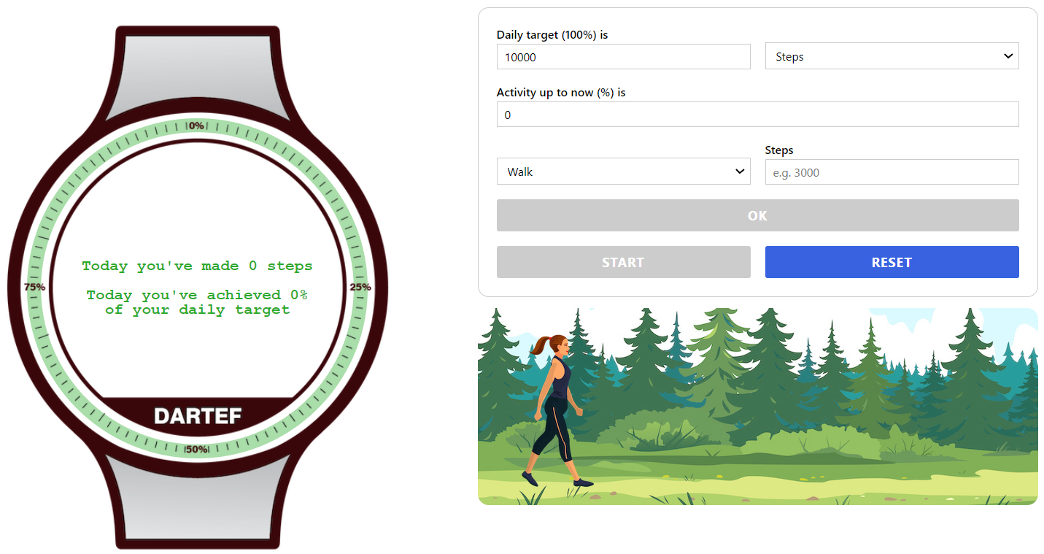
10000 steps is the daily target by default – but it can be changed.
1. Insert here number – how many steps You want person to walk.
2. Press OK and then START. Observe, how the daily activity percentage is changing while person is walking.
Press RESET to insert new values.

Exercises (solve in written and then check Your answer with the help of program):
- Keep 10000 steps as daily target. Answer the questions:

- The person wakes up Saturday morning and wants to go for training in order to achieve 100% of daily target. How many steps the person must make?
Answer: the person must walk ______ steps in order to achieve 100% of daily activity, because (write how You calculated that) _____________________________________________________________.

- How many steps the person must make in order to achieve 1% of daily activity?
Answer: the person must walk ______ steps in order to achieve 1% of daily activity, because (write how You calculated that) _____________________________________________________________.

- The person wakes up Sunday morning and want to go for a walk. Because it’s Sunday, the person decides that it is not necessary to make 100% today. How many steps the person must make to achieve 25%, 33%, 50% of the daily target?
Answers:
- the person must walk ______ steps in order to achieve 25% of daily activity, because _____________________________________________________________.
- the person must walk ______ steps in order to achieve 33% of daily activity, because _____________________________________________________________.
- the person must walk ______ steps in order to achieve 50% of daily activity, because _____________________________________________________________.

- The person came home in the evening and saw, that his activity monitor shows, that 35% of the daily target was achieved during the day. So, (s)he decides to go for a walk and to make remaining steps, in order to fulfil 100%. How many steps (s)he needs to make to achieve 100%?
Hint: since the person has already made 35% of the daily target – insert this number into program: 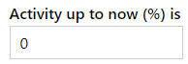
Answer: the person made 35% during the day, which corresponds to _____ steps. Therefore, if daily target is 10000 steps, s(he) needs to make _______ steps more in order to achieve 100%.

- Your own daily target
The trained person must make more than 10000 steps per day – for example 12500 steps per day to achieve 100% daily target. At the same time, the person who is less trained, shouldn’t make too much training – it can cause injuries. For that reason, activity monitors allow to enter Your own daily target. What do You think – what must be Your own daily target? Insert this target into program and repeat same exercises as above.
Answers:
- My daily target is ______ steps per day. Therefore, I should walk ______ steps in order to achieve 1% of daily activity, because (write how You calculated that) _____________________________________________________________.

- I should walk ______ steps in order to achieve 25% of my daily activity, because _____________________________________________________________.
- I should walk ______ steps in order to achieve 33% of my daily activity, because _____________________________________________________________.
- I should walk ______ steps in order to achieve 50% of my daily activity, because _____________________________________________________________.

- I made 35% during the day, which corresponds to _____ steps. Therefore, if my daily target is _______ steps, I need to make _______ steps more in order to achieve 100%.

- Minutes instead of steps
Obviously, it is not always convenient to plan training by counting steps. Activity monitors allow also to use minutes for planning training. Usual daily target is 90 minutes of walking per day. Insert this number into program and make following exercises.

Answers:
- Daily target is 90 minutes per day. Therefore, person must walk ______ minutes in order to achieve 10% of daily activity, because (write how You calculated that) _____________________________________________________________.

- One should walk ______ minutes in order to achieve 30% of my daily activity, because _____________________________________________________________.
- One should walk ______ minutes in order to achieve 40% of my daily activity, because _____________________________________________________________.
- One should walk ______ minutes in order to achieve 50% of my daily activity, because _____________________________________________________________.

- If person made 40% during the day, it corresponds to _____ minutes. Therefore, if the daily target is _______ minutes, (s)he need to make _______ minutes more in order to achieve 100%.

Topics for classroom discussion (or short essay, if worksheet is given as homework):
  - How many steps (minutes) my family make per day in average – and what is the percentage of it, if daily target must be 10000 steps?
  - What percentage of students in our class make less then 10000 steps per day? More than 10000 per day?
  - What percentage of the daily target I usually do while I am in school?

Possible students’ questions and answers to these:
Q: My mom/dad does have activity monitor – and there You don’t have to enter steps for daily target!
A: This is because activity monitors can be programmed to calculate daily target itself. And people who create these activity monitors know how to make these activity monitors to calculate it properly.

