Common fractions: introduction, basic property and fraction transformation.
https://dartef-education.web.app/SNA_11a
Fountain show is incredibly beautiful show, there are a lot of different fountain shows. For example, there are shows where fountains are given special shape, there are shows, when fountains are following music, there fountains that are made together with light show. You can have a look Yourself, for example in YouTube: try searching “singing fountains”.
How these fountain shows are made? Well, there is a lot of methods to control fountains – even manually. However, it is reliable to use mathematical methods. In order to use mathematical methods – we need first of all to describe fountains in mathematical language. Common fraction is one example of mathematical language. Following software will show, how it can be possible.
The program has four fountains, each of them has 7 water pipes:
Use this field to insert „unit height“ – measured in meters. For example 1, or 2.
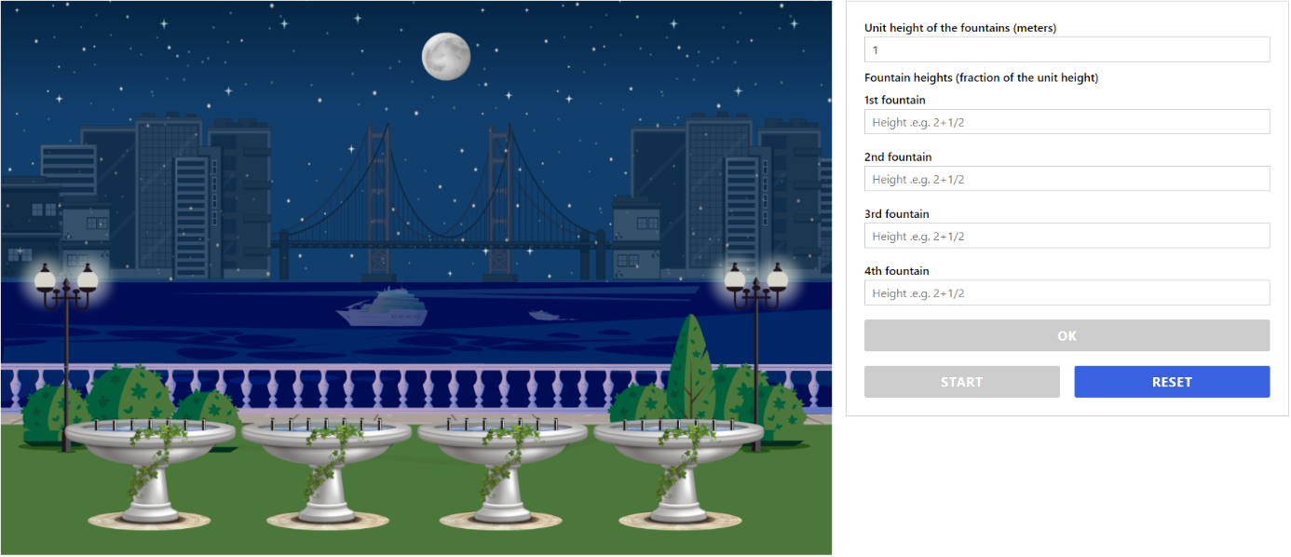
When everything is inserted press OK and then START. To insert new values press RESET
Insert here height of each fountain – as a fraction of the unit height

Introductory exercises:

Let’s agree, that “usual” height of the water stream is 1 meter high. Let’s call it “unit height” and insert “1” into software. If we want all four fountains to splash water at 1 meter height, then insert 1 for all fountains. Press OK and then start – to see, that all four fountains splash water to 1 meter height. In order to check water stream height – hover mouse over fountain:
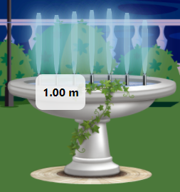

We can make fountains to splash water higher that one meter. For example – if our unit height is 1 meter and we want fountains to be 2 meters high – insert 2 for each fountain. Try it.

We can also make different fountains to splash water into different heights. If our unit height is 1 meter, and we want every fountain to splash water higher than previous, we can put „1“, „2“, „3“ and „4“ in each fountain field. It means, that 1st fountain splashes water at the same height as unit height, 2nd fountain – two times higher than unit height, 3rd fountain – 3 times higher and 4th fountain – 4 times higher than unit height. Try this, or any other shapes of the fountains.

Until now, we could do everything without fractions. However, if we want our fountains to be for example higher than 1 meter but smaller than 2 meters – using fractions is very convenient. For example, if we want fountain to be 1 meter and one third – then just put “1+1/3”. Try it.

Using common fractions allows us to make fountain smaller than 1 meter. For example, we can put one third of a meter – 1/3 as fountain height. Try it.

Exercises (solve in written and then check Your answer with the help of program):
- Put 1 meter as unit height. Make fountains 20 cm high. Hint: in how many parts You need to divide 1 meter in order to get 20 cm? What fraction have You got?
Answer: 1 meter must be divided into ____ parts in order to get 20cm. Therefore, fraction is ____.

- Put 2 meters as unit height. Make fountains again 20cm high. What fraction have You got this time?
Answer: 2 meters must be divided into _____ parts in order to get 20 cm. Therefore, fraction is ____.

- Put 3 meters as unit height. Make fountains 50cm high. What fraction have You got?
Answer: 3 meters must be divided into _____ parts in order to get 50 cm. Therefore, fraction is ____.

- Put 2 meters as unit height. Make fountains 1 meter high. What fraction have You got?
Answer: 3 meters must be divided into _____ parts in order to get 50 cm. Therefore, fraction is ____.

- Put 1 meter as unit height. Make fountains 1 meter and 50 cm high. What fraction have You got? Is it proper fraction or improper fraction?
Answer: 1 meter and 50cm is _____ of 1 meter. This is proper/improper fraction, because___________________________________________________________________________.

- Put 2 meters as unit height. Make fountains 2 meters and 50cm. What fraction have You got? Is it proper fraction or mixed fraction?
Answer: 2 meters and 50cm is _____ of 2 meters. This is proper/improper fraction, because___________________________________________________________________________.

- Put 3 meters as unit height. Make fountains 3 meters high, whereas use fraction that has denominator of 2; b) 3; c) 10; d) 80. How many different options there is to write it?
Answer: If the unit height is 3 meters, then in order to make fountains 3 meters high we can use fractions: $\frac{}{2}$,$\frac{}{3}$,$\frac{}{10}$,$\frac{}{80}$. There is total of ______ different ways to write necessary fraction.

- Put 2 meters as unit height. Make fountains 2 meters and 50 cm, whereas insert improper fraction for fountains nr. 1 and 2 and mixed fraction for fountains nr. 3 and 4.
Answer: Fraction necessary for fountains nr. 1 and 2 is ______ and for fountains 3 and 4 is _____.

- Put 1 meter as unit height. Make fountains 3 meters high. What fraction have You got? Then put 3 meters as unit height – and make fountains again 3 meters hight. What fraction have You got this time?
Answer: if unit height is 1 meter, then we need fraction _____ to make fountains 3 meters high. But if unit heigh is 3 meters than we need fraction _______ to make fountains again 3 meters high.

- Put 2 meters as unit height. Make fountain 3 meters high. What fraction have You got? Give answer as improper fraction and as mixed fraction.
Answer: if unit height is 2 meters, then improper fraction necessary to make fountains 3 meters high is ______ and mixed fraction to make fountains 3 meters high is _______.

Topics for classroom discussion (or short essay, if worksheet is given as homework):
  - Is it convenient to use fractions for controlling fountains?
  - Is there anything else, that we could control with the fractions?
  - Can You propose other ways to control fountains?
  - Can we use fractions to control fountains and light altogether?

Possible students’ questions and answers to these:
Q: What can’t we just write height of fountains (like “2 meters 50 centimetres”). Why is it necessary to use fractions?
A: Because water pumps doesn’t understand “2 meters 50 centimetres”. Water pump can work quicker or slower. We can put water pump to work quicker or slower using fractions.

„Usual“ mean, that fountain water pump works with normal speed

